Initial Reconfigurable Virtual Cockpit Trainers (RVCT) delivered to the U.S. Army PEO-STRI in Orlando for Evaluation
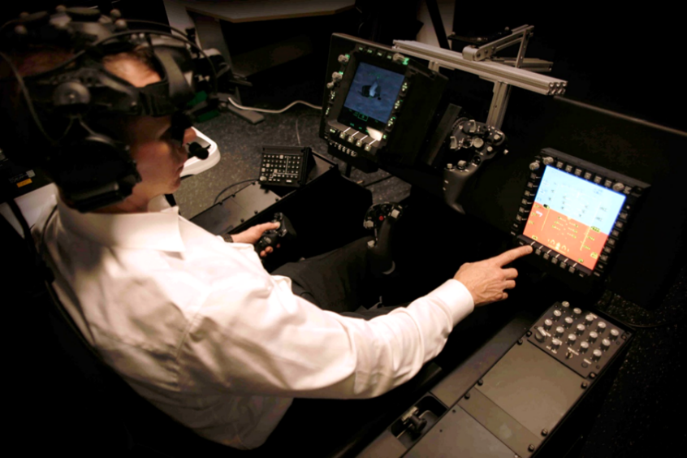
(Union, Missouri) Bugeye Technologies, Inc. has recently completed delivery of Reconfigurable Virtual Cockpit Trainers (RVCT) as a part of the U.S Army Synthetic Training Environment (STE) OTA 1. The deliveries include multiple versions of mixed reality rotorcraft reconfigurable cockpit systems, man-in-the loop Unmanned Aerial Systems (UAS), as well as six virtual reality door gunner trainers. The RVCT systems are Bugeye’s second and third generation designs that have evolved through tight cooperation with the U.S. Army Futures Command and PEO-STRI over the past year.
Read the full press release here: http://www.asdnews.com/news/defense/2019/09/25/initial-rvct-delivered-us-army-peostri-orlando-evaluation

